**DO THE BELOW PROGRAMS IN ANONYMOUS FUNCTION & IIFE**

**TASK A : PRINT ODD NUMBERS IN AN ARRAY**

for(i=10; i<=20; i++){

    // let's divide the value by 2.

    // if the remainder is not a zero then it's an odd number.

    if(i % 2 != 0){

    console. log(i);

    }

    }

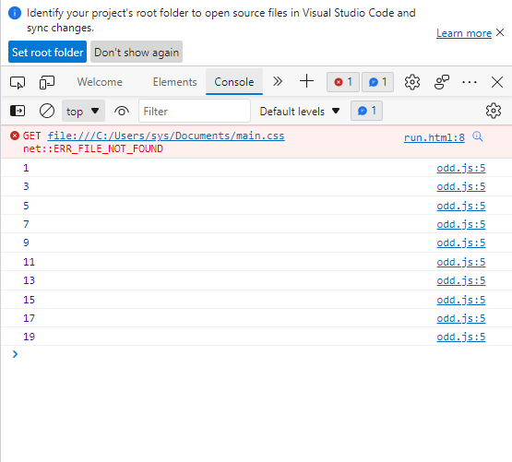

**TASK B: CONVERT ALL THE STRINGS TO TITLE CAPS IN A STRING ARRAY**

String.prototype.toProperCase = function() {

    var words = this.split(' ');

    var results = [];

    for (var i = 0; i < words.length; i++) {

      var letter = words[i].toUpperCase();

      results.push(letter);

    }

    return results.join(' ');

  };

  console.log(

    'praveen kumar'.toProperCase()

  )

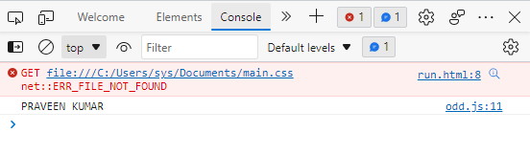

**TASK C : SUM OF ALL NUMBERS IN AN ARRAY**

console.log(

    eval([5,8,6].join('+'))

  )

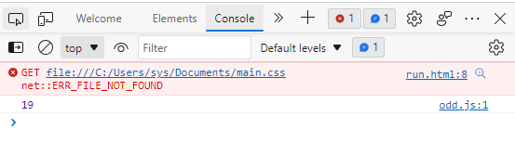

**TASK D : RETURN ALL THE PRIME NUMBERS IN AN ARRAY**

const array = [-5, -3, -2, -1, ...Array(20).keys()];

// Array(20).keys() generates numbers from 0 to 19.

function isPrime(num) {

  for (let start = 2; num > start; start++) {

    if (num % start == 0) {

      return false;

    }

  }

  return num > 1;

}

console.log(array.filter(isPrime)); // [2, 3, 5, 7, 11, 13, 17, 19]

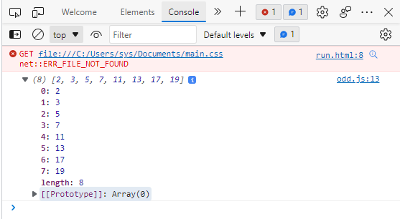

**TASK E : RETURN ALL THE PALINDROMES IN AN ARRAY**

let arr = ["for", "racecar", "pineapple", "porcupine", "pineenip",'pap','lol'];

let palindromes = arr.filter(w => {

  let len = w.length;

  for (let i = 0; i < len / 2; i++) {

    if (w[i] == w[len - i - 1]) {

      return true;

    } else {

      return false;

    }

  }

});

console.log(palindromes)

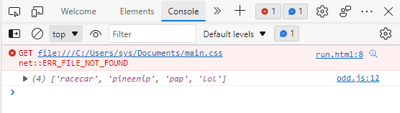

**TASK G : REMOVE DUPLICATES FROM AN ARRAY**

let animals = ["Lion", "Rabbit", "Mouse", "Monkey", "Lion","Ape"]

let usingFilter = () => {

return unique = animals.filter(function(item,index){

      return animals.indexOf(item) == index;

   });

}

console.log(usingFilter())

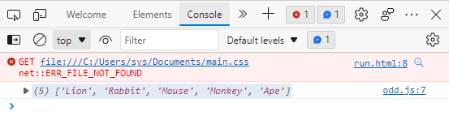

**TASK H : ROTATE AN ARRAY BY K TIMES**

function startday() {

    const days = ['Sun','Mon','Tue','Wed','Thu','Fri','Sat'];

    let today = new Date();

    let start = today.getDay(); //gets day number

    if (start == 0) { //if Sunday, days are in order

        return days

    }

    else { //if not Sunday, start days with today

        return days.slice(start).concat(days.slice(0,start))

    }

}

console.log(startday());

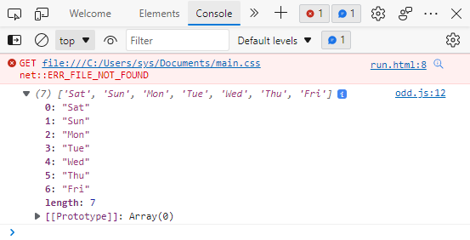

**DO THE BELOW PROGRAMS IN ARROW FUNCTIONS**

**TASK A : PRINT ODD NUMBERS IN AN ARRAY**

let arr = [1,2,3,4,5,6,7,8,9,10,11,12]

let odds = arr.filter(n => n%2)

console.log(odds)

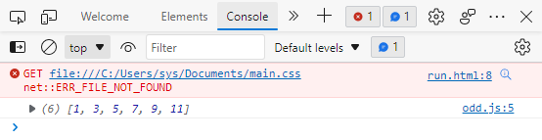

**TASK B : CONVERT ALL THE STRINGS TO TITLE CAPS IN A STRING ARRAY**

var str = "foo bar baz"

console.log(

str.split(' ')

   .map(w => w.toUpperCase())

   .join(' ')

)

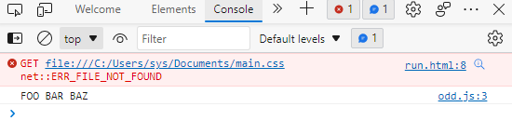

**TASK C : SUM OF ALL NUMBERS IN AN ARRAY**

const sum = [1, 2, 3].reduce((partial_sum, a) => partial_sum + a, 0);

console.log(sum);

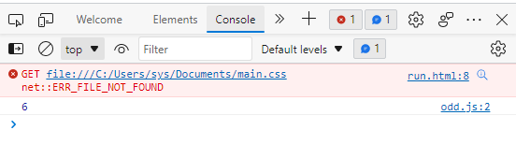

**TASK D : RETURN ALL THE PRIME NUMBERS IN AN ARRAY**

var numArray = [2, 3, 4, 5, 6, 7, 8, 9, 10]

numArray = numArray.filter((number) => {

  for (var i = 2; i <= Math.sqrt(number); i++) {

    if (number % i === 0) return false;

  }

  return true;

});

console.log(numArray);

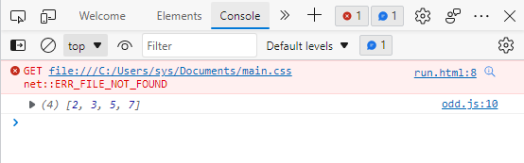

**TASK E : ALL THE PALINDROMES IN AN ARRAY**

let arr =  ['foo', 'racecar', 'pineapple', 'porcupine', 'pineenip']

let palindromeArr = []

arr.forEach(word => {

  if (isPalindrome(word)) {

    palindromeArr.push(word)

  }

})

console.log(palindromeArr)